**CS 487 DATA SECURITY**

**HOP03 – Deploy Key Vault**

12/16/2020 Developed by Mary Oh

Center for Information Assurance (CIAE) @City University of Seattle (CityU)

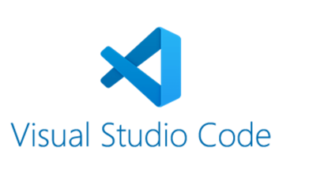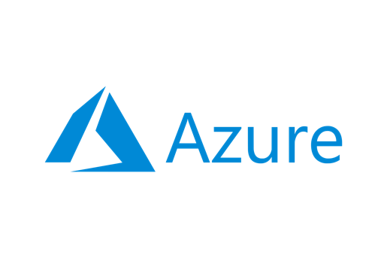

**Before You Start**

* Version numbers may not match with the most current version at the time of writing. If given the option to choose between stable release (long-term support) or most recent, please choose the stable release rather than beta-testing version.
* This tutorial targets Windows users and MacOS users.
* There might be subtle discrepancies along the steps. Please use your best judgement while going through this cookbook style tutorial to complete each step.
* For your working directory, use your course number. This tutorial may use a different course number as an example.
* The directory path shown in screenshots may be different from yours.
* If you are not sure what to do or confused with any steps:
  + Consult the resources listed below.
  + If you cannot solve the problem after a few tries, ask a TA for help.

**Learning Outcomes**

* Create an Azure key vault and key by using ARM template

**Resources**

* Microsoft Azure - [https://azure.microsoft.com/](https://azure.microsoft.com/en-us/overview/what-is-azure/?&ef_id=Cj0KCQiAlsv_BRDtARIsAHMGVSac9cd8I7htfl0EVYTYDUBxYJ7mEqQ6dB5bRem2ziaBp-j1Di4wui8aAivlEALw_wcB:G:s&OCID=AID2100131_SEM_Cj0KCQiAlsv_BRDtARIsAHMGVSac9cd8I7htfl0EVYTYDUBxYJ7mEqQ6dB5bRem2ziaBp-j1Di4wui8aAivlEALw_wcB:G:s&gclid=Cj0KCQiAlsv_BRDtARIsAHMGVSac9cd8I7htfl0EVYTYDUBxYJ7mEqQ6dB5bRem2ziaBp-j1Di4wui8aAivlEALw_wcB)
* Microsoft Documentation - <https://docs.microsoft.com/>

**What is Azure?**

Azure cloud platform is cloud services designed to help bring new solutions to life. You can build, run, and manage application across multiple clouds, on-premises, and at the edge, with the tools and frameworks of your choice.

**What is Azure Key Vault?**

Azure Key Vault is a cloud service that provides a secure storage for secrets such as keys, passwords, certificates, and other secrets.

**Using ARM template**

1. Download the keyvault.json file. This is an ARM template for creating a key vault in Azure.
2. Open the json file with Visual Studio Code.
3. Open the integrated Visual Studio Code terminal using ctrl + ` key.
4. Sign in using your Azure account information. This will open up a new window to sign in.

1. Create the resource group.

1. Open your browser and log in to your Azure account. Go to the arm-vscode resource group and modify the access control. Add yourself as the owner and save.

1. Back in the VSCode integrated terminal, enter the following command to obtain your object ID. Replace the email with your Azure email.



1. Deploy the template. Type the following command. Ensure you are in the correct directory where the file is saved.
   1. Enter your name as the “keyVaultName”.
   2. Enter the ID returned as your “objectId”
   3. Enter an appropriate “secretName”
   4. Enter the value of the secretName selected.

1. Verify deployment and creation of the key vault was successful.

1. To avoid incurring any unnecessary fees, clean up resources. Type the following command in your terminal and enter y.



1. Verify clean up was successful. Head to your Azure in your web browser and refresh. The arm-vscode resource group should not be showing.
2. Purge the key-vault created. Select the key vault and click purge.

**Push your work to GitHub**

1. Open the integrated Visual Studio Code terminal using ctrl + ` key. Make sure you are in the right path.
2. Type the following command:

git add . (to copy all changes you have made)

git commit -m “Submission for Module 3 - YourGitHubUsername” (To add a message to your submission)

git push origin master (to upload your work to Github)